Assignment:

Please do implement the BM25 search index in your mongo db and update the env file with you respective mongo details.

Please complete the above assignment on creating the BM25 search index.

BM25 Index creation in MongoDB:

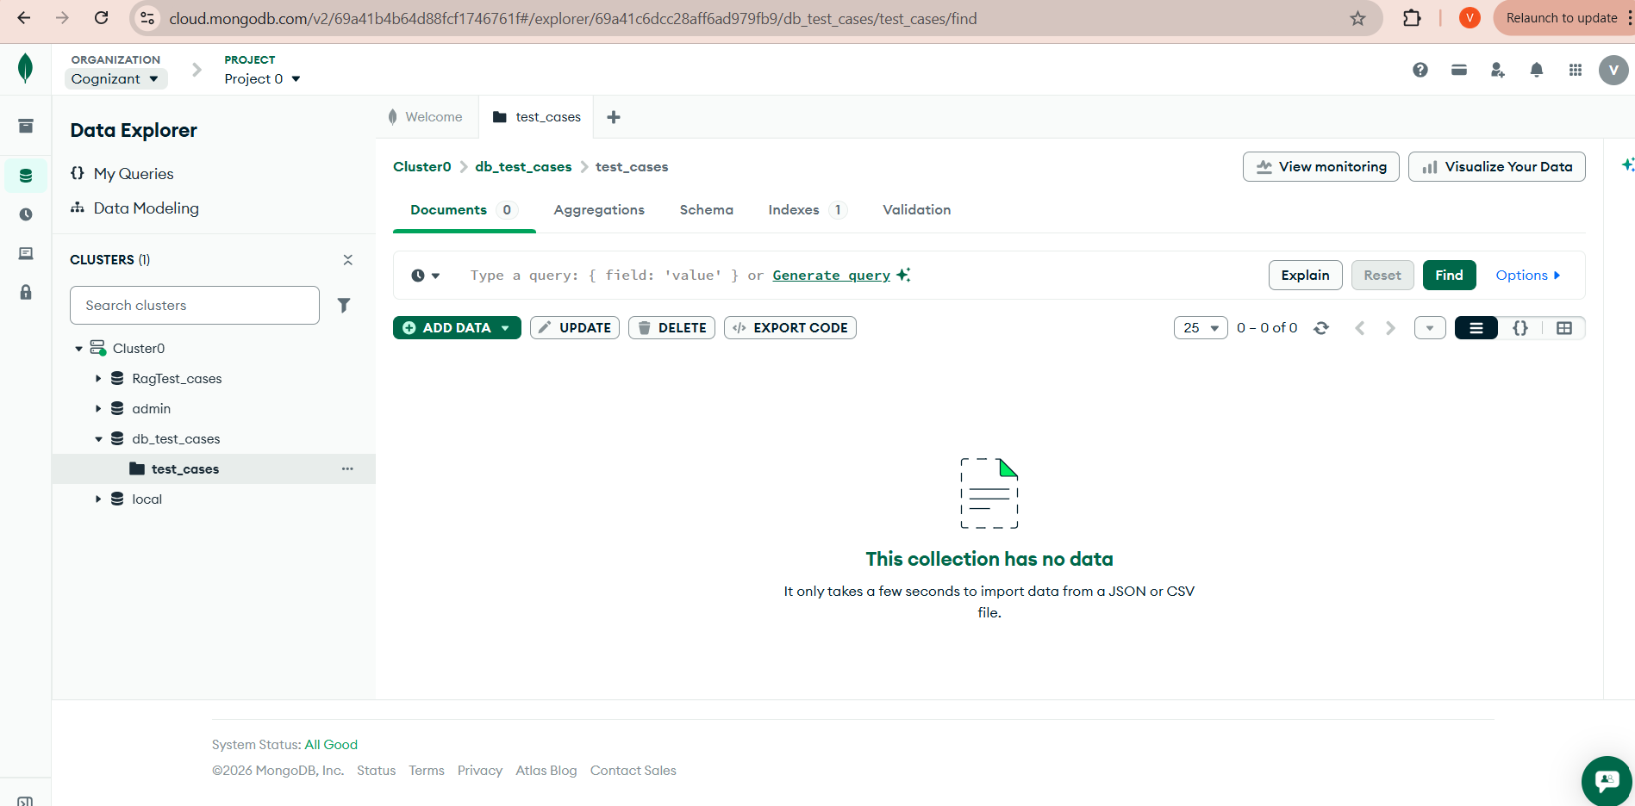

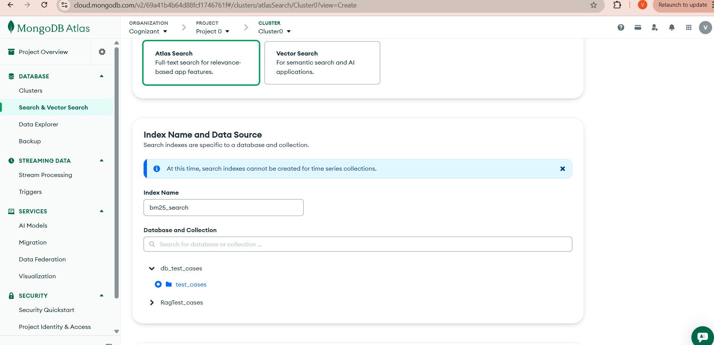

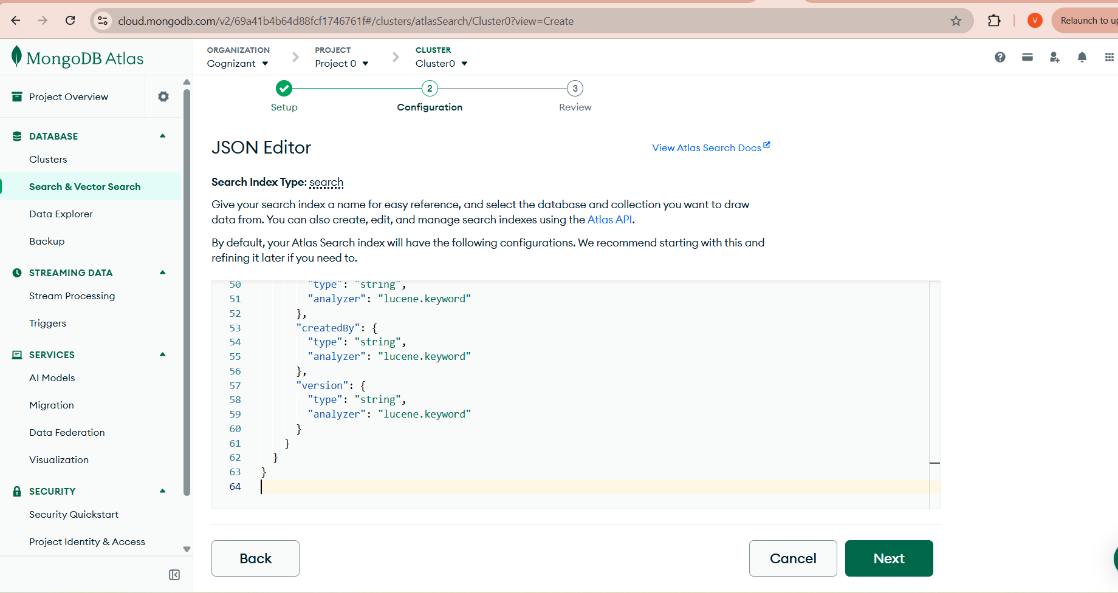

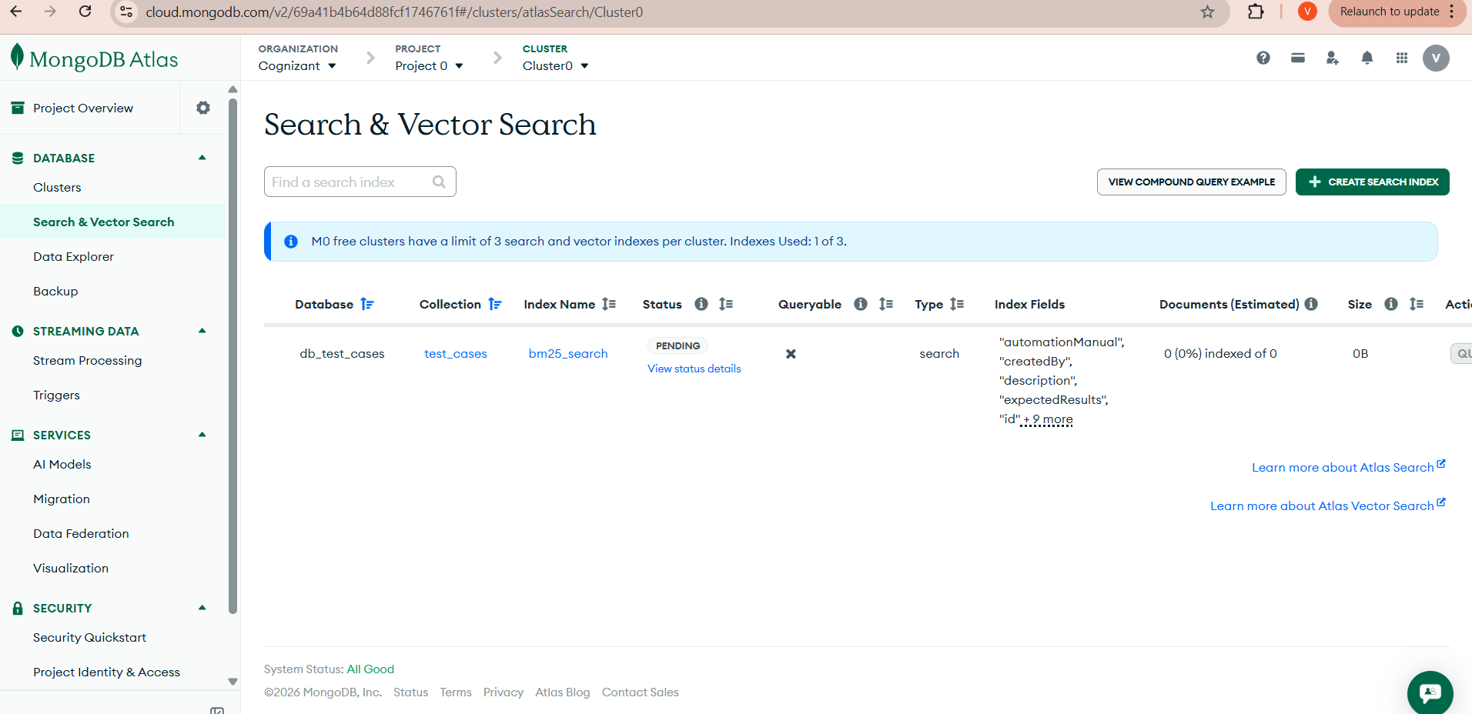

Env update:
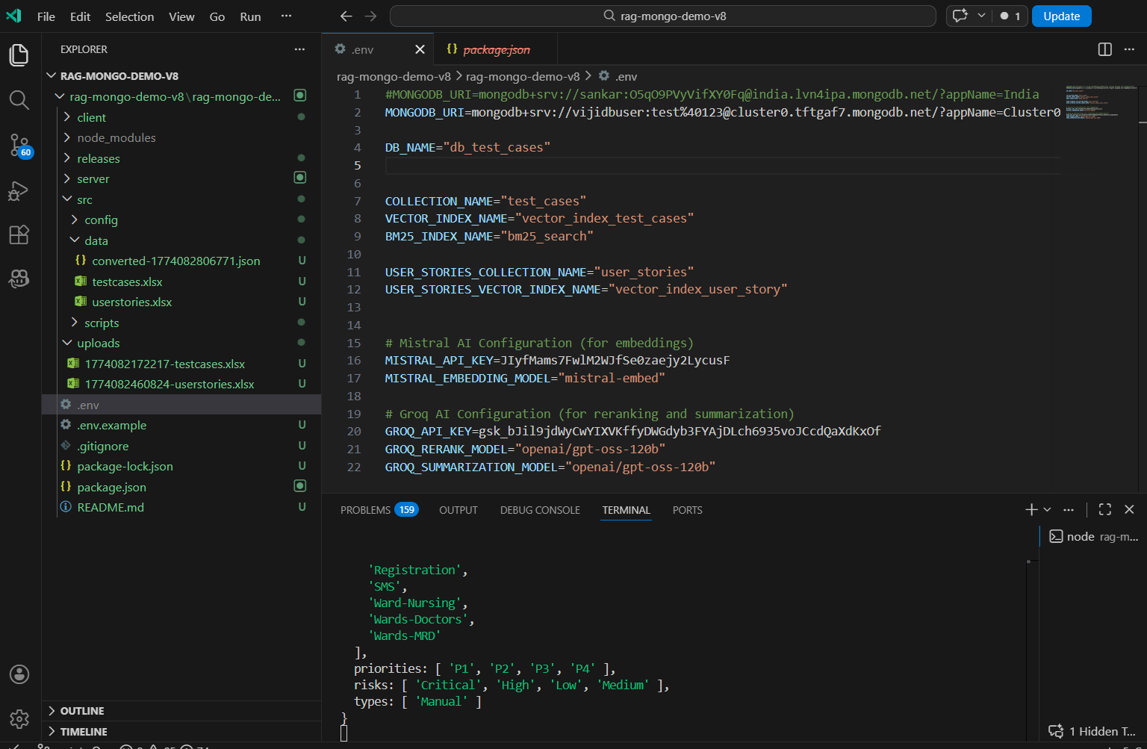

Test case ingestion:

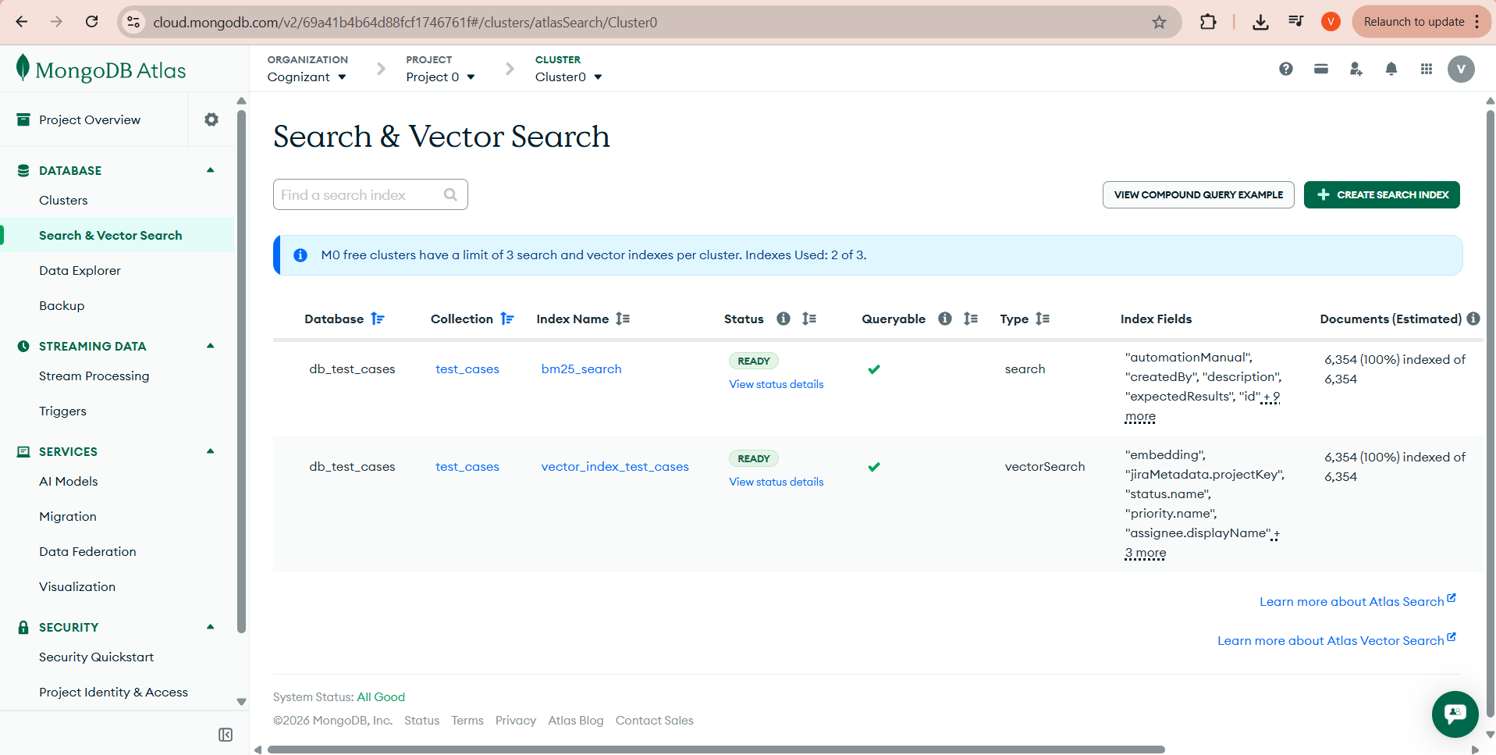

Query Processing:

Query Preprocessing & Search
Transform your query through normalization, abbreviation expansion, and synonym generation before searching
Enter Your Query
Quick Examples:

Query Transformation Pipeline

📝 ORIGINAL QUERY

"password reset OTP verification"

1️⃣ NORMALIZATION

"password reset otp verification"
4 tokens

2️⃣ ABBREVIATION EXPANSION
1 expansions

"password reset one time password verification"
Expanded:
otp → one time password

3️⃣ SYNONYM EXPANSION
5 variations
Multiple query variations generated for comprehensive search coverage
1. "password reset one time password verification"
2. "credential reset one time password verification"
3. "passphrase reset one time password verification"
+ 2 more variations

Processing Metadata
Processing Time
0ms
Token Count4
Abbreviations1
Synonyms3

How Query Preprocessing Works
1. Normalization: Converts text to lowercase, removes special characters, extracts test case IDs
2. Abbreviation Expansion: Expands healthcare abbreviations (UHID → unique health id, OTP → one time password)
3. Synonym Expansion: Generates multiple query variations using synonyms (patient → customer/user/individual)
4. Search Execution: Uses all variations to perform comprehensive search with better recall

